1. **What is SQL? What is DML? What is DDL? Recite the most important SQL commands.**

SQL (Structured Query Language) is a special-purpose programming language designed for managing data held in a relational database management system (RDBMS).

A data manipulation language (DML) is a family of syntax elements similar to a computer programming language used for selecting, inserting, deleting and updating data in a database.

A data definition language or data description language (DDL) is a syntax similar to a computer programming language for defining data structures, especially database schemas.

1. **What is Transact-SQL (T-SQL)?**

Transact-SQL (T-SQL) is Microsoft's and Sybase's proprietary extension to SQL.

1. **Start SQL Management Studio and connect to the database TelerikAcademy. Examine the major tables in the "TelerikAcademy" database.**

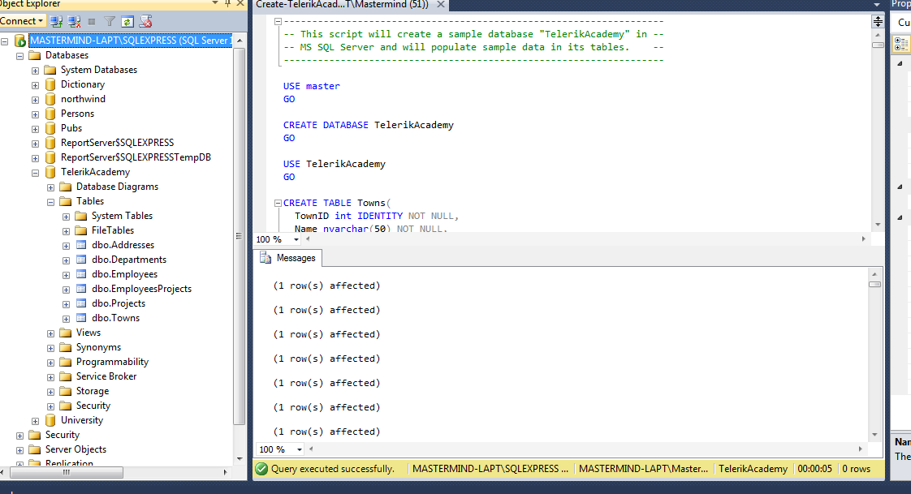

1. **Write a SQL query to find all information about all departments (use "TelerikAcademy" database).**

Select * from Departments

1. **Write a SQL query to find all department names.**

Select Name from Departments

1. **Write a SQL query to find the salary of each employee.**

Select Salary from Employees

1. **Write a SQL to find the full name of each employee.**

Select FirstName + ' ' + LastName as [FullName] from Employees

1. **Write a SQL query to find the email addresses of each employee (by his first and last name). Consider that the mail domain is telerik.com. Emails should look like “John.Doe@telerik.com". The produced column should be named "Full Email Addresses".**

Select FirstName + '.' + LastName + '@telerik.com' as [Full Email Addresses] from Employees

1. **Write a SQL query to find all different employee salaries.**

Select distinct salary from Employees

1. **Write a SQL query to find all information about the employees whose job title is “Sales Representative“.**

Select * from Employees where JobTitle = 'Sales Representative'

1. **Write a SQL query to find the names of all employees whose first name starts with "SA".**

Select FirstName, LastName from Employees where FirstName like 'SA%'

1. **Write a SQL query to find the names of all employees whose last name contains "ei".**

Select FirstName, LastName from Employees where LastName like '%ei%'

1. **Write a SQL query to find the salary of all employees whose salary is in the range [20000…30000].**

Select Salary from Employees where Salary between 20000 and 30000

1. **Write a SQL query to find the names of all employees whose salary is 25000, 14000, 12500 or 23600.**

Select FirstName, LastName from Employees where Salary in (25000, 14000, 12500 , 23600)

1. **Write a SQL query to find all employees that do not have manager.**

Select * from Employees where ManagerId IS NULL

1. **Write a SQL query to find all employees that have salary more than 50000. Order them in decreasing order by salary.**

Select * from Employees where Salary >= 50000

Order by Salary desc

1. **Write a SQL query to find the top 5 best paid employees.**

Select top 5 * from Employees

order by Salary desc

1. **Write a SQL query to find all employees along with their address. Use inner join with ON clause.**

Select e.FirstName, e.LastName, a.AddressText, t.Name from (Employees e inner join Addresses a on e.AddressID = a.AddressID) inner join Towns t on a.TownID = t.TownID

1. **Write a SQL query to find all employees and their address. Use equijoins (conditions in the WHERE clause).**

Select e.FirstName, e.LastName, a.AddressText from Employees e, Addresses a where e.AddressID = a.AddressID

1. **Write a SQL query to find all employees along with their manager.**

Select e.FirstName + ' ' + e.LastName as [Employee], m.FirstName + ' ' + m.LastName as [Manager] from Employees e inner join Employees m on m.EmployeeID = e.ManagerID

1. **Write a SQL query to find all employees, along with their manager and their address. Join the 3 tables: Employees e, Employees m and Addresses a.**

Select e.FirstName + ' ' + e.LastName as [Employee], a.AddressText + ', ' + t.Name as [Address], m.FirstName + ' ' + m.LastName as [Manager]

from ((Employees e inner join Employees m on m.EmployeeID = e.ManagerID)

inner join Addresses a on a.AddressID = e.AddressID)

inner join Towns t on a.TownID = t.TownID

1. **Write a SQL query to find all departments and all town names as a single list. Use UNION.**

Select Name from Departments

UNION

Select Name from Towns

1. **Write a SQL query to find all the employees and the manager for each of them along with the employees that do not have manager. Use right outer join. Rewrite the query to use left outer join.**

Select e.FirstName + ' ' + e.LastName as [Employee], m.FirstName + ' ' + m.LastName as [Manager] from Employees e right outer join Employees m on m.EmployeeID = e.ManagerID

Select e.FirstName + ' ' + e.LastName as [Employee], m.FirstName + ' ' + m.LastName as [Manager] from Employees e left outer join Employees m on m.EmployeeID = e.ManagerID

1. **Write a SQL query to find the names of all employees from the departments "Sales" and "Finance" whose hire year is between 1995 and 2005.**

Select * from Employees e inner join Departments d on e.DepartmentID = d.DepartmentID

where d.Name in ('Sales', 'Finance')

and YEAR(e.HireDate) between 1995 and 2005